Ozevac is a small, specialised Company offering a very personalised, high quality service.

As such, we have lower operating costs, we are extremely competitive in our quotations without compromising our high standards of care or level of medical equipment.

We offer all of the medical services available from larger Companies, but **Ozevac** is totally independent and our loyalties lie entirely with the patients’ best interests.

* **Ozevac** is operated by a medical team with over 30 years experience in caring for critically ill & injured patients.
* **Ozevac** utilises the services of specialist senior doctors, Critical Care Nurses and Intensive Care Paramedics
* The **Ozevac** team has over 30 years experience in medical retrieval, nationally and internationally.
* **Ozevac** uses some of the latest medical equipment and Lear jet air ambulances equipped with Lifeport stretchers. Our expert doctors & nurses are specifically chosen to meet the individual needs of each case.
* **Ozevac** provides the best care & service, focused on the best possible outcomes for the patients

**We are proud to use the equipment and services of:**

[logo_laerdal](http://www.laerdal.com.au/)

* [LSU Suction Unit](https://ozevac.com/laerdal-lsu-unit/)

[logo_jetcity](http://www.jetcity.com.au/)

[logo_zoll](http://www.zoll.com.au/)

* [Zoll AED Pro](https://ozevac.com/aed-pro-automated-external-defibrillator/)
* [Zoll X Series](https://ozevac.com/m-series-cct-defibrillator/)
* Zoll Z Vent Ventilator

[logo_ferno](http://www.ferno.com.au/)

* [Ferno EXL Scoop Stretcher](https://ozevac.com/exl-scoop-stretcher/)
* [Ferno Easy Fix Vacuum Mattress](https://ozevac.com/easy-fix-vacuum-mattress/)

[logo_draeger](http://www.draeger.com/)

* [Drager Oxylog 3000 Plus](https://ozevac.com/oxylog-3000-plus/)

Can we change the order and tidy these company labels up and find a way of making the links look nicer?

We could have the company logo and small tabs to link to the equipment information connecting to our page as currently

[**PRODUCTS**](https://www.zoll.com/au)

**Under ZOll ,** need to remove M series CCT details and replace with

1. Zoll X Series Monitor /defibrillator and directed by a link to the words & image below

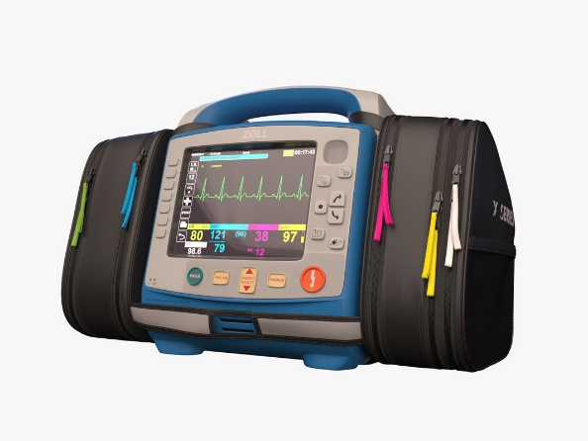 **ZOLL X Series Monitor/Defibrillator**

In the ever-changing world of EMS, you need to ensure the monitor/defibrillator you buy today will keep pace with the progressive vision of pre-hospital care.

The ZOLL X Series® Monitor/Defibrillator, built on an expandable platform, addresses EMS needs now and moving forward. Likely half the weight of what you carry today, it delivers the capabilities you expect from a full-featured monitor designed for use with all patients, ranging from neonates through adults.

* **the Zoll AED Pro** is the same piece of equipment and the link connects the way it should

**Zoll – [** new equipment is] Zoll Z series ventilator

The link needs to connect with

[**https://www.zoll.com/au/products/ventilators/z-vent-for-ems**](https://www.zoll.com/au/products/ventilators/z-vent-for-ems)

But should just show

* + [**PRODUCTS**](https://www.zoll.com/au)

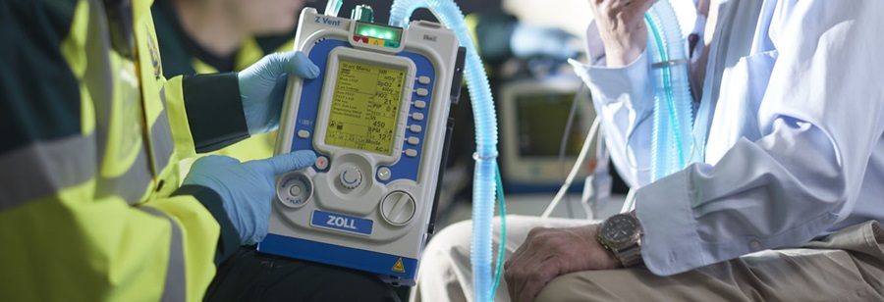

## Ventilation Simplified

# Z Vent for EMS

The Z Vent® ventilator is easy to use, portable, durable, and rugged. Designed to be lightweight and energy-efficient, Z Vent is ideal for all types of transport: ground ambulances, critical care transports, and air transports.

Weighing less than 10 pounds (4.5kg), with a battery runtime of 10 hours, Z Vent is the ideal portable ventilator supporting infants through adults. The ruggedized housing is built to military standards, withstanding the elements that EMS personnel may face on any given day. With an integrated energy-efficient compressor, Z Vent helps conserve oxygen during transports where every bit of oxygen counts.

**Draeger Medical** should be next, the Oxylog 3000+ is the same piece of equipment and the link connects the way it should

**Laerdal** – same logo, same piece of equipment and the link connects the way it should

**Jetcity** has a new logo.

I have attached the Jetcity Logo Guidelines to the email if you need

**Ferno** - all unchanged

**Fresenius** – need to add a company logo for Fresenius



The page to look at is <https://www.fresenius-kabi.com/my/products/injectomat-agilia>

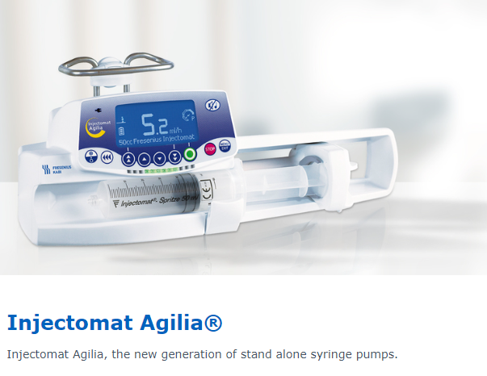

Features

* Flow rate range: 0.1- 200 ml/h (depending on the syringe capacity - up to 1200 ml/h).
* Flow rate accuracy: ± 1% on mechanism ; ± 2 % on syringes.
* Infusion Modes:
  + ml/h (0.1 ml/h increments).
  + Volume / time: Volume to infuse 0.1 to 99.9 ml /
  + Time: 0 h 01 to 96 h 00.
  + Volume limit: 0.1-999.9 ml (0.1 ml increments).
* Bolus: Manual bolus: Rate 50-1200 ml/h (50 ml/h increments).
* Drug library: Initial drug list of 50 agents adjustable with Vigilant®, the IV Medication Safety Solution. Adjustment of the dilution, authorised infusion modes, default infusion modes, flow rate and bolus limits in ml/h.
* Pressure modes: 2 modes available: variable or 3 pre-set levels - From 100 to 900 mmHg, 50 mmHg increment.
* DPS: The Dynamic Pressure System - DPS - warns of pressure variations. A risk of obstruction or a possible leak in the infusion line can thus be anticipated.
* Anti-bolus system: Reduces significantly bolus after occlusion release (0.2 ml max).
* Dimensions (H/W/D/) / Weight: 160 x 345 x 135 mm / 2150 g.
* Battery: NI/MH / Battery capacity minimum: 10 hours at 5 ml/h / Battery replacement: separate compartment – no need for electrical security testing.